NASA Ames Mars Global Climate Model Software Development Plan

**1. Introduction** **3**

1.1 Purpose 3

**2. Related Documents** **3**

**3. Architectural Design** **3**

3.1 GCM Introduction 3

3.2 The Physical Processes 3

3.4 Model Diagram 4

**4. Implementation** **5**

**5. Software Storage and Maintenance** **6**

**6. Software Costs** **6**

**REFERENCES** **6**

# 1. Introduction

## 1.1 Purpose

This document contains the software development plan and architectural design for the NASA Ames Mars Global Climate Model; hereinafter referred to as the “GCM.”

# 2. Related Documents

* NASA Ames Mars Global Climate Model Software Requirements Document
* NASA Ames Mars Global Climate ModelVerification and Validation Plan

# 3. Architectural Design

## 3.1 GCM Introduction

The GCM simulates the climate of the planet Mars using an external finite volume dynamical core to predict the global atmosphere given various planetary parameters and physical parameters. The software described in this document includes only the physical processes and patches to interface with the external model, as the dynamical core is a third party software package available at GitHub.com developed by the Geophysical Fluid Dynamics Laboratory (GFDL) at the National Oceanic and Atmospheric Administration (NOAA).

## 3.2 The Physical Processes

The model physics routines describe inputs to the system and conversion within the atmosphere of energy and mass; these codes compute radiation, turbulence, cloud microphysical processes, etc. The majority of the effort of developing Mars-specific GCMs goes into developing such physics routines appropriate for the Martian environment. The GCM group at NASA Ames Research Center has been developing and implementing physics packages for several decades.

## 3.3 Model Diagram

The following is a flow chart for the software described in this document. The modules are listed in the order they are called, with yellow flags indicating if the module can be turned off via namelist flags. The red path represents the path the software follows in the case the hs_forcing flag is false. The green paths represent alternative options offered by the model.

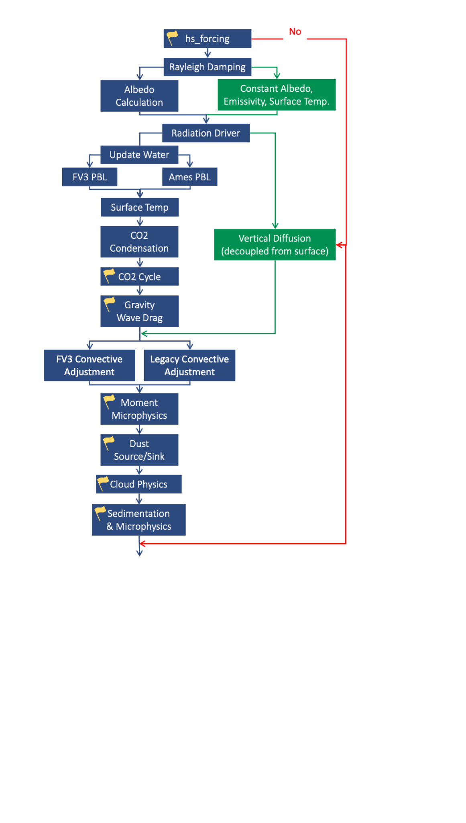

# 4. Implementation

The GCM is written in Fortran code. Detailed requirements are listed in the software requirements document. A sample compile script is included with the source code. The GCM can be compiled by linking to the appropriate libraries and executing the compile script. Upon successful completion, an executable will be created. This executable can be copied to a directory where the program shall be run and output shall be created. A sample run script with default parameters is included.

All software components of the GCM were developed and supplied using NASA resources. Surface maps for thermal inertia, albedo, and residual north polar cap boundary were created by team members and collaborators at Oregon State University. Dust optical properties were supplied by Michael Wolff at Space Science Institute in Boulder, CO. All other input data was supplied by NASA.

# 5. Software Storage and Maintenance

The GCM software source code shall be stored and maintained with changes tracked and documented on the NASA public GitHub repository located at: <https://github.com/nasa>

This software will receive regular updates at the GitHub repository, which will include updated descriptions of software capabilities. These will be communicated to community members via GitHub notifications and regular communications from the NASA Ames Mars Climate Modeling Center (MCMC). The software will be released as a submodule to be used with the NOAA/GFDL AM4 model. Included patches will be applied to interface the NASA software with AM4. This software will continue to be developed as long as the MCMC performs Mars modeling research and development. Updates shall be communicated to GitHub as long as NASA maintains a public repository.

The software status shall be evaluated regularly. In the event of a software audit, the project manager shall participate, along with principal developers. If the software evolves to a higher or lower classification, this and the supporting documents shall be updated accordingly.

# 6. Software Costs

This software is under active development which is funded by the MCMC. The MCMC is funded by the NASA Internal Scientist Funding Model (ISFM). The MCMC has allocated approximately 7 FTE for the purposes of developing, testing, releasing, and maintaining the model, as well as costs associated with community engagement. The MCMC has an independent working group to monitor progress and provide guidance for model development. We minimize required development costs by taking advantage of open source software developed by NOAA/GFDL, i.e. the AM4 framework and the accompanying cubed sphere dynamical core. All other new software shall be developed internally with allocated funding.

# 7. Potential Software Reuse

This GCM is designed to work as a standalone software package and not intended for reuse. However, certain portions of the model could be separated in order to perform specific functions within other software packages. These include the microphysics subroutines for predicting dust and water ice evolution, radiation transfer subroutines for predicting fluxes in a Mars-like atmosphere, soil temperature subroutines for predicting surface temperatures, and boundary layer mixing using a Mellor-Yamada level 2.0 prediction.

# 8. Software Development Schedule

The MCMC regularly consults with an independent working group of advisors to maintain a software development schedule, with planned feature updates as well as community service activities such as tutorial workshops.

# 9. Cybersecurity Assessment

This software does not include any off-the-shelf software, and has been screened for PII or other sensitive information. The software is self-contained and does not include the capability for remote communication, therefore does not pose a cybersecurity risk. Active software development is performed using the NASA commercial github internal repository, located at <https://developer.nasa.gov> in order to minimize security risks.

# REFERENCES

Bertrand, T., Wilson, R. J., Kahre, M. A., Urata, R., & Kling, A. (2020). Simulation of the 2018 Global Dust Storm on Mars Using the NASA Ames Mars GCM: A Multitracer Approach. Journal of Geophysical Research: Planets, 125(7), 1–36. https://doi.org/10.1029/2019JE006122